Windows GraphViz安装与配置

http://www.graphviz.org/download/
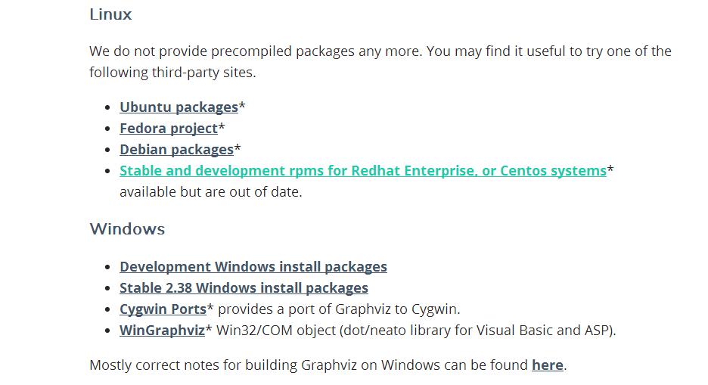
https://graphviz.gitlab.io/_pages/Download/Download_windows.html
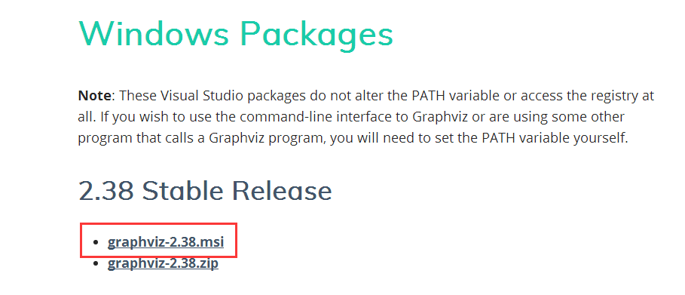
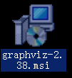

点击直接安装下一步

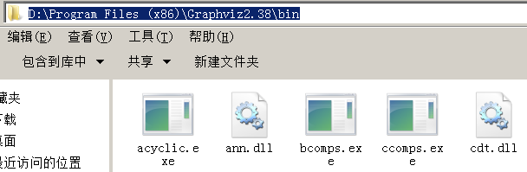

;D:\Program Files (x86)\Graphviz2.38\bin
